**Better work-life balance would shrink the gender pay gap**

[Print](https://eige.europa.eu/print/news/better-work-life-balance-would-shrink-gender-pay-gap)[Download as PDF](https://eige.europa.eu/printpdf/news/better-work-life-balance-would-shrink-gender-pay-gap)

**NEWS ARTICLE**

**TOPICS:**

[Economic and financial affairs](https://eige.europa.eu/topics/economic-and-financial-affairs), [Employment](https://eige.europa.eu/topics/employment)

**PUBLICATION DATE:**

29 May 2019

[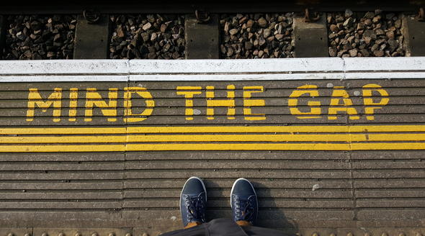](https://eige.europa.eu/sites/default/files/styles/eige_original_optimised/public/images/shutterstock_396331873.jpg?itok=YAGEorvK)

Photo: Ivan Guardino / Shutterstock

**The gender pay gap reveals the different realities that women and men face in their professional and personal lives. Today, women across the EU earn on average, 16% less per hour than men. The biggest gap in earnings is among couples with children - showing that the financial cost of having a family falls heavily on women’s shoulders.**

These findings are from a new report published today by the European Institute for Gender Equality (EIGE).

“Women are using flexible work arrangements to juggle work and family life but this is rarely the case for men. Our report shows that work-life balance initiatives can help to boost women’s employment and close the gender pay gap, but only if both women and men have support from their employers to take advantage of these measures,” said Virginija Langbakk, EIGE’s director.

The gender pay gap is a result of many factors: women are concentrated in lower level and lower paid jobs, work more (both paid and unpaid) hours, take longer career breaks, and are more likely to choose part-time work to reconcile work and care responsibilities. The price to pay is high: in the EU, women’s pensions end up being 37% less than men’s.

“We must get rid of gender stereotypes that underpin the pay gap, starting with the uneven concentration of women and men in the labour market. Women dominate fields that are less valued and lower paid, such as education or care work. At the same time, women are less likely to be in top management roles and this needs to change,” said Ms Langbakk.

Even higher education does not protect women from earning less. Women with a tertiary degree face a higher pay gap of 25%. As they move up the career ladder, the pay gap widens.

The European Union is committed to ensure a better work-life balance for its citizens and reduce the gender pay gap. The European Commission’s Proposal for a Directive on Work-Life Balance for Parents and Carers aims to improve access to parental leave and flexible working, as well as increase the take up of these arrangements by men. The EU Action Plan, designed to reduce the gender pay gap includes a variety of policy options to combat pay inequalities. These include equal pay for equal work, getting more women into top-level management positions and encouraging companies to attract and retain women or men into jobs where they are underrepresented.

Read our report [Tackling the gender pay gap: not without a better work-life balance](https://eige.europa.eu/publications/tackling-gender-pay-gap-not-without-better-work-life-balance)